Development Environment Setup

Manish Basnet

2026 Summer - Artificial Intelligence for Human-Computer Interaction (MSAI-631-M90)

Dr. Dennis

May 2026

Step 1: Miniconda Installation
I usually create virtual environments for Python, but I wanted to try Anaconda, so I started by installing miniconda to keep it simple.
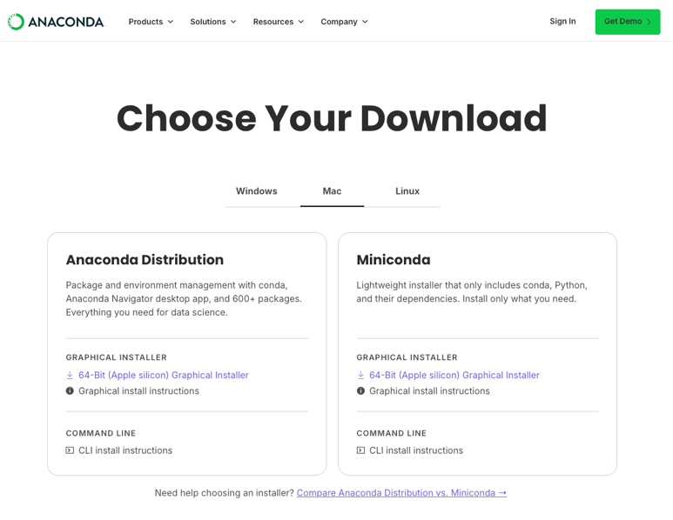
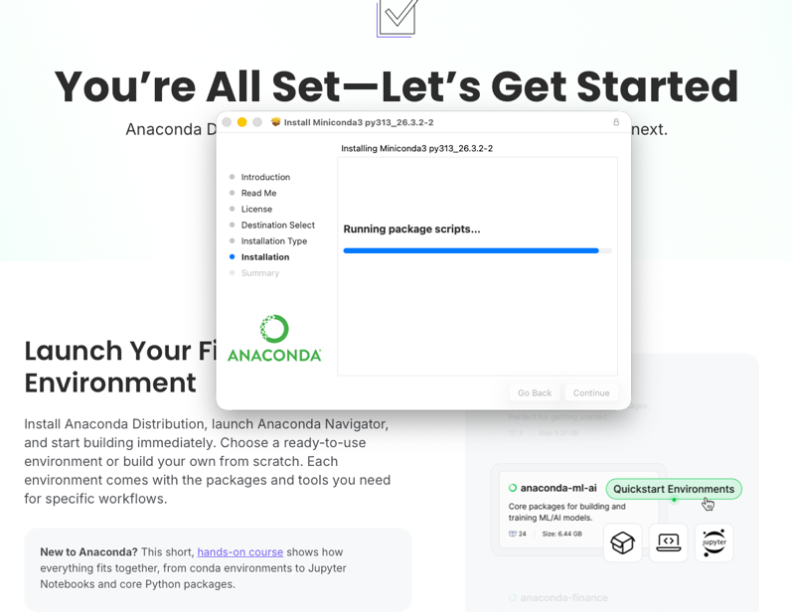

Step 2: Verify Correct Installation
Then, to verify installation, as instructed in the Getting Started section, I ran this command and confirmed the correct installation by checking the list of installed packages.
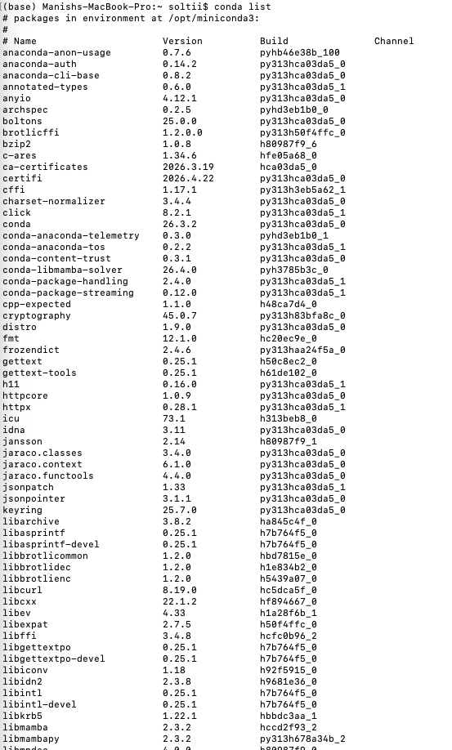
Step 3: Create and activate a conda environment
I created the env ai4hci with the Python 3.11 interpreter. I chose this version because I have learned from some personal projects that most libraries have stable builds for it. I have occasionally experienced performance issues with TensorFlow on the newer builds (3.13 and later), but it is stable on this specific build.
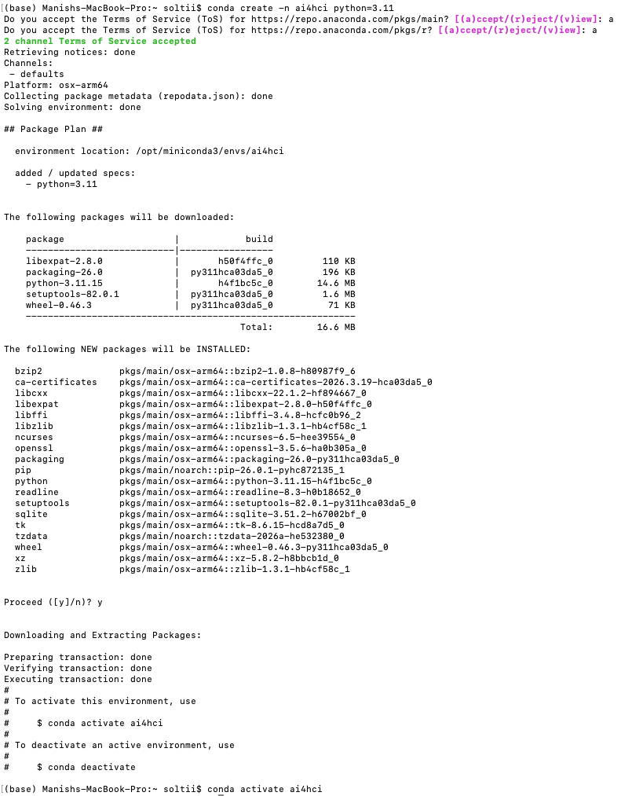

Step 4: Add some relevant packages to the environment
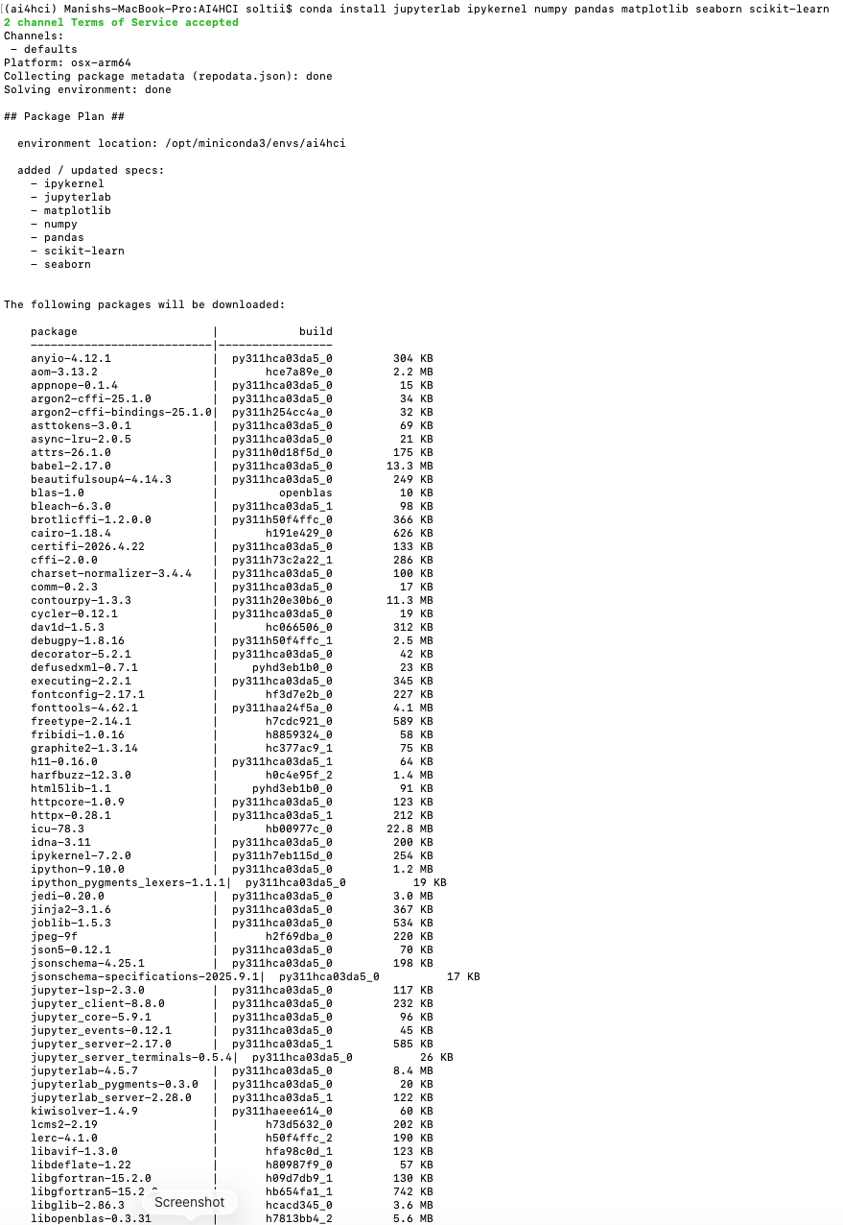
I added some modules and packages that I have prior experience with and that I thought might be relevant to our coursework.

Step 5: Start a JupyterLab server and create a notebook
I created a new notebook using the ipykernel. In the notebook, I first verified whether the kernel was in fact Anaconda’s environment kernel. With that confirmation, I went ahead and wrote a Lorenz attractor script that demonstrates the butterfly effect (a chaotic system whose output is highly sensitive to small changes in its initial conditions). So in our script, if the state array is even changed to [0.,1.,1.051], we will see a shape that diverges completely from the current shape.
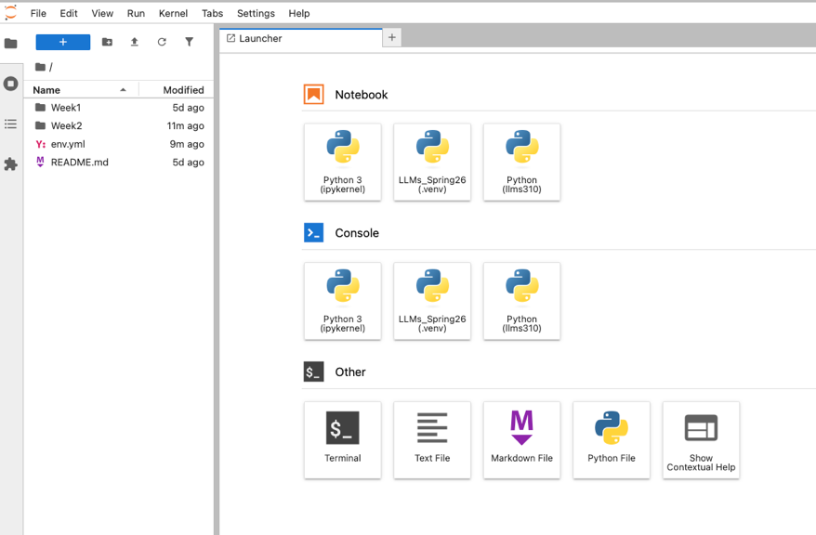
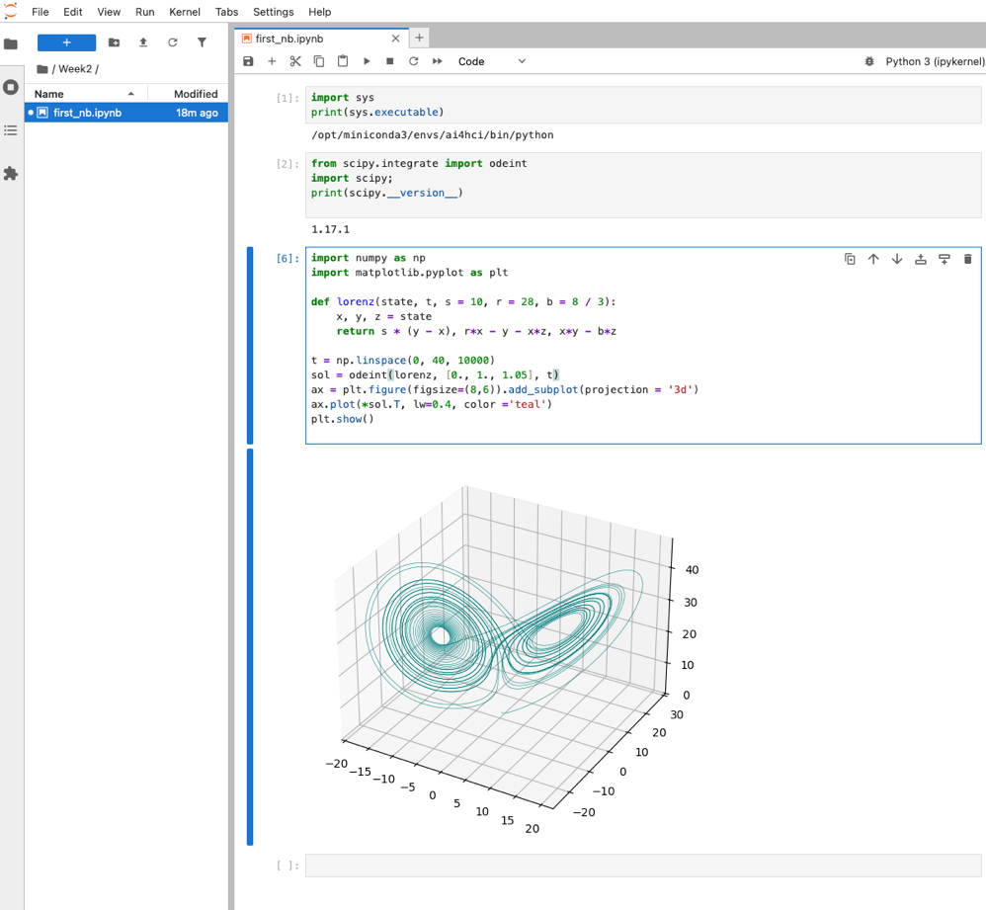
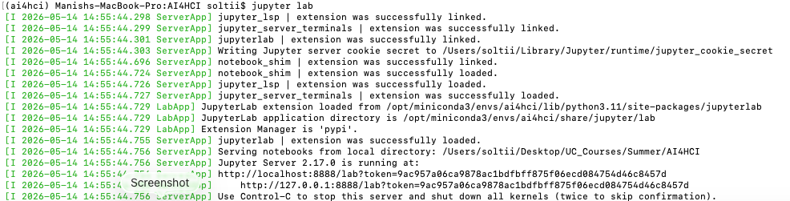
Step 6: Update Interpreter for Python files and Jupyter servers
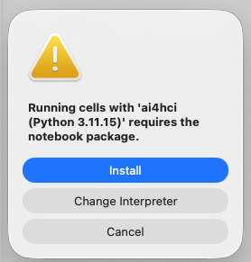
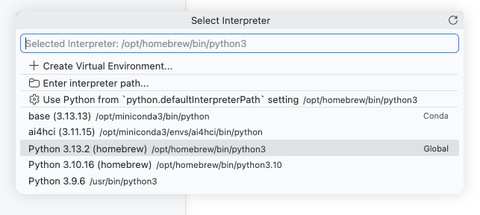
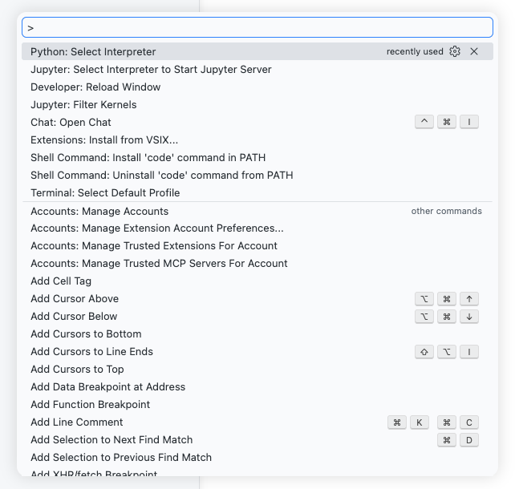
I have been using VSCode for some years now, so I updated the interpreters for times when I might find using VSCode more convenient. I was also prompted to install the notebook package into the ai4hci env I created in the previous steps.
Step 7: Export Environment and push to GitHub
While unnecessary, I export the environment setup to a .yml file that reproduces my exact environment. I ensure the notebook and this document live inside Week 2 and push to GitHub.

References
Intro to conda workflows - Anaconda. https://www.anaconda.com/docs/getting-started/working-with-conda/conda-intro-tutorial
macOS graphical installer - Anaconda. https://www.anaconda.com/docs/getting-started/miniconda/install/mac-gui-install
macOS graphical installer - Anaconda. https://www.anaconda.com/docs/getting-started/miniconda/install/mac-gui-install
Lorenz attractor - Matplotlib 3.10.9 documentation. https://matplotlib.org/stable/gallery/mplot3d/lorenz_attractor.html

